Web Api > It uses HTTP Action verbs

Get > Read Data

Post > Create

Put > Edit

Delete > Delete

using System;

using System.Collections.Generic;

using System.Linq;

using System.Threading.Tasks;

using Microsoft.AspNetCore.Mvc;

using WebApplication16.Models;

// For more information on enabling Web API for empty projects, visit https://go.microsoft.com/fwlink/?LinkID=397860

namespace WebApplication16.Controllers

{

[Route("api/[controller]")]

[ApiController]

public class StudentController : ControllerBase

{

// GET: api/<StudentController>

static List<Student> students = null;

public StudentController()

{

if (students == null)

{

students = new List<Student>()

{

new Student(){ Id=1, Name="Aashna", BatchCode="DotNet", Marks=90},

new Student(){ Id=2, Name="Priynaka", BatchCode="DotNet", Marks=87},

new Student(){ Id=3, Name="Tisha", BatchCode="SAP", Marks=98},

new Student(){ Id=4, Name="Naveen", BatchCode="SAP", Marks=90},

new Student(){ Id=5, Name="Siddhant", BatchCode="DotNet", Marks=90},

new Student(){ Id=6, Name="Vaibhav", BatchCode="DotNet", Marks=90},

};

}

}

// GET: api/Student

[HttpGet]

public IEnumerable<Student> Get()

{

return students;

}

// GET: api/Student/5

[Route("{id:int}")]

public Student Get(int id)

{

return students.FirstOrDefault(x => x.Id == id);

}

// POST: api/Student

[HttpPost]

public void Post(Student student)

{

students.Add(student);

}

// PUT: api/Student/5

[HttpPut]

[Route("{id:int}")]

public void Put(int id, Student student)

{

(from p in students

where p.Id == id

select p).ToList()

.ForEach(x =>

{

x.Name = student.Name;

x.BatchCode = student.BatchCode;

x.Marks = student.Marks;

}

);

}

// DELETE: api/Student/5

[HttpDelete]

[Route("{id:int}")]

public void Delete(int id)

{

Student student = students.FirstOrDefault(x => x.Id == id);

students.Remove(student);

}

}

}

While Post

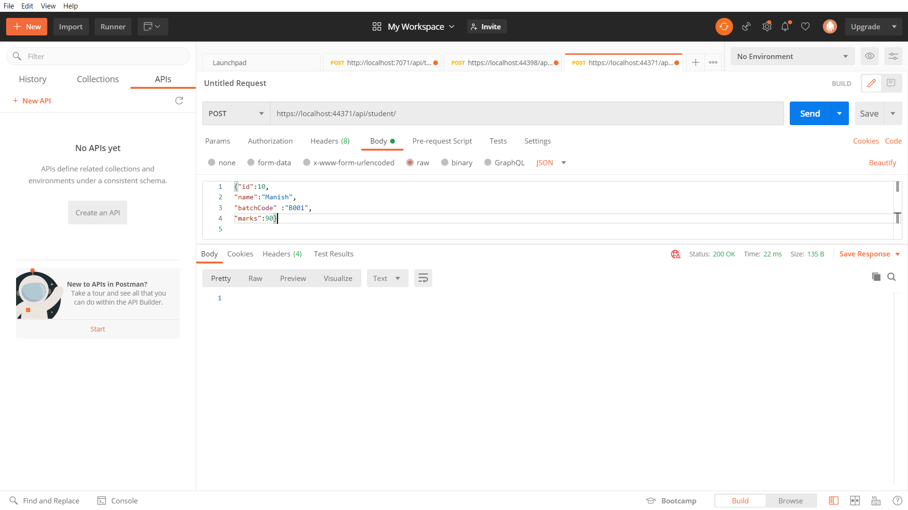

{"id":10,

"name":"Manish",

"batchCode" :"B001",

"marks":90}

HttpResponseMessage

System.Net.Http

System.Net.Http.Formatting

IActionResult

using System;

using System.Collections.Generic;

using System.Linq;

using System.Net.Http;

using System.Threading.Tasks;

using Microsoft.AspNetCore.Mvc;

using WebApplication16.Models;

// For more information on enabling Web API for empty projects, visit https://go.microsoft.com/fwlink/?LinkID=397860

namespace WebApplication16.Controllers

{

[Route("api/[controller]")]

[ApiController]

public class Student1Controller : ControllerBase

{

static List<Student> students = null;

public Student1Controller()

{

if (students == null)

{

students = new List<Student>()

{

new Student(){ Id=1, Name="Aashna", BatchCode="DotNet", Marks=90},

new Student(){ Id=2, Name="Priynaka", BatchCode="DotNet", Marks=87},

new Student(){ Id=3, Name="Tisha", BatchCode="SAP", Marks=98},

new Student(){ Id=4, Name="Naveen", BatchCode="SAP", Marks=90},

new Student(){ Id=5, Name="Siddhant", BatchCode="DotNet", Marks=90},

new Student(){ Id=6, Name="Vaibhav", BatchCode="DotNet", Marks=90},

};

}

}

// GET: api/<Student1Controller>

[HttpGet]

public IActionResult Get()

{

if (students != null)

return Ok(students);

else

return NotFound();

}

// GET api/<Student1Controller>/5

[HttpGet("{id}")]

public IActionResult Get(int id)

{

Student student = students.FirstOrDefault(x => x.Id == id);

if (student != null) return Ok(student);

else

return NotFound();

}

// POST api/<Student1Controller>

[HttpPost]

public IActionResult Post(Student student)

{

Student temp = students.FirstOrDefault(x => x.Id == student.Id);

if (temp == null)

{

students.Add(student);

return Created("Record Created" , student);

}

else

return Ok("Duplicate");

}

// PUT api/<Student1Controller>/5

[HttpPut("{id}")]

public void Put(int id, [FromBody] string value)

{

}

// DELETE api/<Student1Controller>/5

[HttpDelete("{id}")]

public void Delete(int id)

{

}

}

}